**National University of Computer & Emerging Sciences, Karachi** 

**Computer Science Department**

**Fall 2024, Lab Manual – 02**

|  |  |
| --- | --- |
| **Course Code: CL-2005** | **Course: Database Systems Lab** |
| **Instructor:** | **Yair Arfat** |

**Contents:**

1. Use of Select Clause (DML/DQL).
2. Use of Column Alias, Concatenation Operator, DISTICNT, ALL keyword and Asterisk Operator.
3. Use of Row Selection Clause (Where).
4. Sorting Results (Use of Order By).
5. Built in Oracle Functions.

**Simple Select Query**:

The purpose of a SELECT statement is to display and retrieve data from one or more database tables. SELECT is the most frequently used command in SQL, and is used to query the database tables. Usually a simple SELECT query involves two more clauses i.e. FROM and WHERE. FROM is used to refer to the tables to retrieve data from.

Syntax: **SELECT <column1>, <column2>…..<column n> FROM <table1>;**

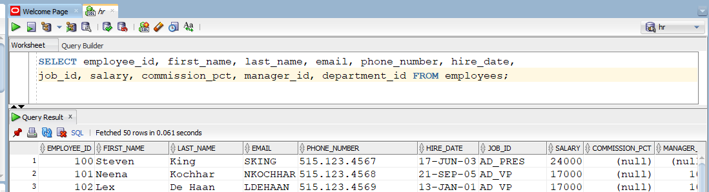Example: **Display all columns of HR Database’s Employee table.**

Task: **Display any two columns from employees table.**

**Use of Column Alias:**

A Column Alias is used to give column a name that is different than the name it is given in the Table. A user usually provides a Column Alias through a special keyword “AS” to display the column with a changed name i.e. Renamed Column.

Syntax: **SELECT <column1> as “New Column Name” FROM <table1>;**

Example: **Display the column Employee_ID and Phone_Number from Employees table. Display the column Phone Number as Contact Number.**

Task: **Display Hire_date from employees table, name it as Joining Date.**

**Use of Concatenation Operator:**

A concatenation operator is denoted by a pipe **||** which is used to concatenate columns or strings together. The pipe operator is independent of the data type of the column.

Syntax: **SELECT <column1> || <column2> FROM <table1>.**

Example: **Show the First Name and Salary of employees as a single column named “Employees and Salaries”.**

Task**:Display the first_name, last_name of Employees together in one column named “FULL NAME”**

**Use of DISTINCT Keyword.**

The distinct keyword is used to show unique records of a table. The SELECT does not eliminate duplicate when it projects over one or more column. To eliminate the duplicates, we use DISTINCT keyword**.**

Syntax**: SELECT DISTINCT <column1> FROM <table1>.**

Example**: Show unique departments of Employees Table.**

**Use of ALL Keyword:**

A query with keyword ALL display all rows irrespective of the duplicate records found in the table. In general it is the reverse of what DISTINCT keyword does.

Syntax**: SELECT ALL <column1> FROM <table1>.**

Example**: Show all salaries of Employees.**

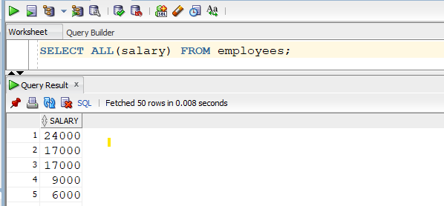

**Use of Asterisk Keyword:**

Many SQL retrieval requires all columns to be displayed in the output, While doing so would be hectic, we use Universal (*) operator to do the same. It is used to show all columns of a table at once.

Syntax**: SELECT * FROM <table1>.**

Example**: Show all columns of table DEPARTMENTS.**

**Row Selection Using WHERE Clause:**

We often need to restrict the number of rows retrieved from the table. This can be done using WHERE clause. The clause uses a search condition or set of search conditions to filter the rows.

Syntax**: SELECT <column1>...<column(n)> FROM <table1> WHERE <column1> = ________;**

Example**: Show the first_name, salary of Employee whose employee id is 100.**

There are Five Possible Types of Search Condition and Operators to be Used:

1. **Comparison Search Condition:** The comparison search condition involves comparison between the column’s actual value and desired value and returns the results filtered using comparison operators (<, >, <=, >= , <> , !=, =). These conditions may involve the use of Logical Operators (AND, OR, NOT) with parameters if needed to show order of evaluation. A search that involves comparison and logical operators together is called Compound Comparison Search Condition.

Example: **List all employees having monthly salaries greater than 1000 and deptno: 100.**

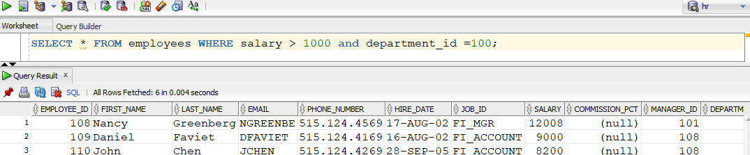

1. **Range Search Condition:** The range search uses BETWEEN and NOT BETWEEN operators to filter the rows on the basis of range of elements. The Between operator includes the endpoints too for search output**.**

Example: **List the staff with the salary between 20,000 and 30,000.**

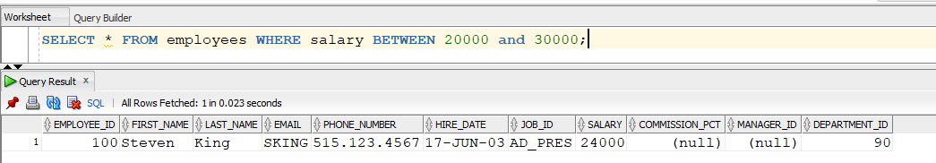

1. **Set Membership Search Condition:** The set membership test (IN) tests whether a data value matches one of a list of values.

Example: **List the salaries of Sales Manager and Purchasing Manager**.

1. **Pattern Match Search Condition:** The search condition involves searching for a particular character or string within a column value. Like Operator with the help of pattern matching symbols ( _, %) are used find patterns in the column’s value. **‘_’ represents a single character while ‘%’ represents a sequence of characters.**

**Example: List all the employees whose names contains an ‘a’ in their first names.**

OR **List all employees having L as second letter in their first names.**

1. **NULL Search Condition**: The NULL Search Condition uses NULL operator to filter fields that have NULL values.

**Example**: Display all employees whose commission is not null.

**Tasks:**

**1)** List all Employees having annual salary greater 20, 000 and lesser than 30,000.

2) List employee_id and first_name of employees from department # 60 to department #100.

3) List all the employees with no commission.

**Sorting Rows with Order by Clause:**

Generally, the rows of an SQL query result table are not arranged in a particular order, however with

the use of Order By clause, the users can arrange the result in a particular ascending or descending

order (alphabetical or numerical) of values present in the fields. The Order By uses column identifiers.

Either these are column names or column numbers.

Syntax: **SELECT <column1>..<column(n)> FROM <table1> Order By <column identifier>.**

Example: **Show all employees in order of their increasing salaries**.

Task: **List all employees in order of their decreasing salaries.**

**DUAL Table in Oracle:**

This is a single row and single column dummy table provided by oracle. This is used to perform mathematical calculations without using a table.

**Syntax:** SELECT * FROM DUAL

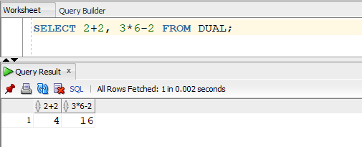

**Built In Oracle Functions:**

Built In Functions area very powerful feature of SQL capable of: performing calculations, modifying individual data, or output for group of rows, format dates and numbers and conversion of column data types. There are two distinct types of functions:

**• Single-row functions:** Single Row or Scalar Functions return a value for every row that is processed in a query.

**• Aggregate Functions:** The group functions are used to calculate aggregate values like total or average, which return just one total or one average value after processing a group of rows.

There are four types of single row functions. They are:

**Numeric Functions**: These are functions that accept numeric input and return numeric values.

The Implementation of these Numeric Functions can be understood from following examples:

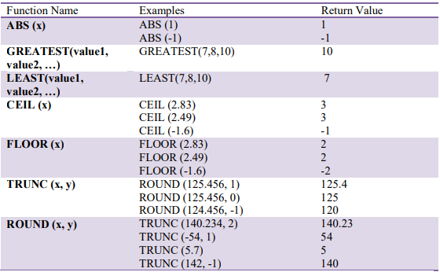

**Character or Text Functions**: These are functions that accept character input and can return

both character and number values. Following are some frequently used char functions:

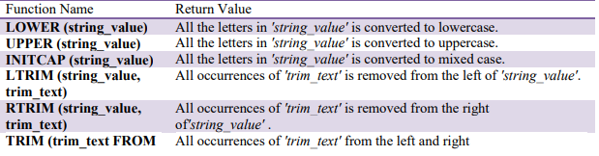

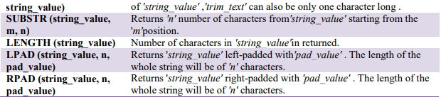

**Following examples illustrate the usage of these functions.**

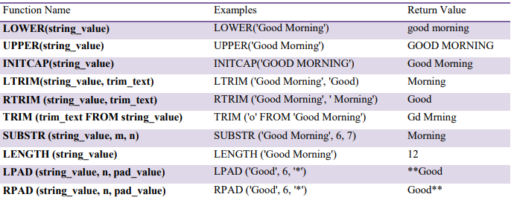

**Date Functions**: These are functions that take values that are of data type DATE as input and

return values of data type DATE, except for the MONTHS_BETWEEN function, which returns a

number.

Functions Description

|  |  |
| --- | --- |
| ADD_MONTHS(date, n) | Returns a date value after adding ‘n’ months to date ‘x’. |
| MONTHS_BETWEEN(x1,x2) | Returns the number of months between date 1& date 2 |
| ROUND(x, date_format) | Returns the date ‘x’ rounded off to the nearest century, year, month, date, hour, minute, or second as specified by the ‘date_format’ |
| TRUNC(x, date_format) | Return the date ’x’ lesser than or equal to nearest century, year, month, date, hour, minute, or second as specified by the ‘date_format’ |
| NEXT_DAY(x, week_day) | Returns the next date of the date ‘week_day’ on or after the date ’x’ occurs. |
| LAST_DAY(x) | It is used to determine the number of days  remaining in a month from the date ‘x’ specified |
| SYSDATE() | Returns the systems current date and time. |
| NEW_TIME(x, zone1, zone2) | Returns the date and time in zone2 if date ‘x’  represents the time in zone1. |

**Implementation:**

Functions Examples Return Value

|  |  |  |
| --- | --- | --- |
| ADD_MONTHS() | ADD_MONTHS (‘16-Sep-81’,3) | 16-DEC-81 |
| MONTHS_BETWEEN() | MONTHS_BETWEEN(’16-SEP-81’, ’16-DEC-81’) | 3 |
| NEXT_DAY() | NEXT_DAY(’01-JUN-08’, ‘Wednesday’) | 04-JUN-08 |
| LAST_DAY() | LAST_DAY(’01-JUN-08’) | 30-JUN-08 |
| NEW_TIME() | NEW_TIME(’01-JUN-08’, ‘ISL’, ‘EST’) | 31-MAY-08 |

**Conversion Functions**: These are functions that help us to convert a value in one form to

another form. For Example: a null value into an actual value, or a value from one datatype to

another datatype like NVL, TO_CHAR, TO_NUMBER, TO_DATE etc.

You can combine more than one function together in an expression. This is known as nesting of

functions.

Following are few examples of conversion functions available in oracle.

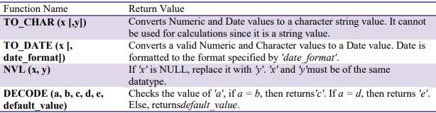

**Implementation:**

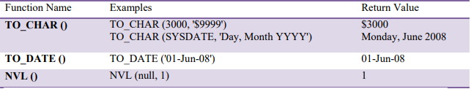

**Tasks:**

1. Print an employee name (first letter capital) and job_id(lower Case)
2. For all employees employed for more than 100 months, display the employee number, hire date, number of months employed, first Friday after hire date and last day of the month hired.
3. Comparing the hire dates for all employees who started in 2003, display the employee number, hire date, and month started using the conversion and date functions.
4. Find the next ‘Monday’ considering today’s date as date.
5. List all Employees who have an ‘A’ in their last names.
6. Show all employees’ last three letters of first name.

**Aggregate Functions (Group Functions):**

A group function is an Oracle SQL function that returns a single result based on many rows, as opposed to single-row functions. These functions are: AVG, COUNT, MIN, MAX, STDDEV, SUM, VARIANCE, etc. Grouping functions may include either of the keywords DISTINCT or ALL.ALL is the default if neither is specified and uses all selected rows in the calculation. DISTINCT uses only one row for each value in the calculations. Note: Group Functions like AVG do not include NULL valued rows. For that we can nest a NULL function into AVG function.

Some Group Functions available in Oracle are:

